

Investigating the maths inside:

Stargazing with the SKA

Activity 1

Heavenly bodies

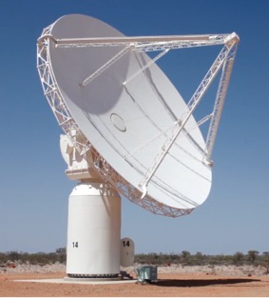

How different from Earth are other planets?

Could we live on any of them?

# Introduction

How many planets of the solar system can you name?

What do you already know about any of these planets?

# My favourite planet

Choose a planet (not Earth) in our solar system.

What can you find out about it? Use the internet to build a mathematical profile and record your information in the table below.

## The facts

Use metric units (such as km and degrees Celcius)

Make sure that you list the sources of your information.

|  |  |
| --- | --- |
| Name of planet |  |
| History: date, name of discoverer (if known) and place of the first known reference of the existence of this planet. |  |
| Rank (in order of distance from the Sun) |  |
| Rank (in order of size, with 1 being the biggest) |  |
| If the distance from the Sun to the Earth is 1, this planet’s distance from the Sun |  |
| If the radius of the Earth’s equator is 1, this planet’s radius of its equator |  |
| If the Earth’s mass is 1, this planet’s mass |  |
| Number of satellites (ie moons) |  |
| Orbital speed |  |
| Orbital distance |  |
| Number of days taken to revolve around the Sun |  |
| Length of day |  |
| Surface gravity (is this more or less than Earth’s?) |  |
| Escape velocity (is this more or less than Earth’s?) |  |
| Number of degrees that the axis tilts |  |
| Temperature range (in degrees Celcius) |  |
| Find three or more other interesting mathematical facts about your planet.  Explain the meaning of any technical terms used. |  |

## How far away?

On a sheet of paper, draw two dots 100 mm apart to represent the average distance from the Sun to the Earth If this was a scale drawing, how far from the Sun should your planet be? Show and explain all your calculations.

## Visit my favourite planet

Create a brochure to entice people to visit your planet.

What will they see? What can they do? What will they need to wear?

# Crux (“Our radiant Southern Cross”)

The constellation Crux, commonly known as the Southern Cross, appears on the Australian flag and is also mentioned in the Australian national anthem.

## The facts

Use the internet to build a mathematical profile of Crux and record your information in the table below.

Use metric units (such as km and degrees Celcius).

Make sure that you list the sources of your information.

|  |  |
| --- | --- |
| What are the names of the five stars in Crux? |  |
| Date, person (if known) and place of the first known reference of the existence of Crux. |  |
| Three or more other interesting mathematical facts about Crux. Explain the meaning of any technical terms used. |  |

## How do I get there?

Make a short video explaining how the Southern Cross can be used to navigate.