

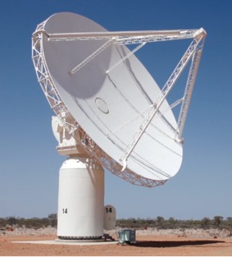Investigating the maths inside:

Stargazing with the SKA

Activity 2B

Very large numbers

What is the biggest number you know?

What is counted in very large numbers?

# Introduction

In 2009, due to very rapid inflation, the government of Zimbabwe produced a 100 trillion dollar note, which was worth about US$30.

|  |  |  |  |
| --- | --- | --- | --- |
| one thousand | = 1000 | = 103 | Therefore 1250 = 1.25  103 |
| ten thousand | = 10 000 | = 104 | Therefore 25 000 =   104 |
| one hundred thousand | = 100 000 | = 10 | Therefore 199 000 =   10 |
| one million | = | = 10 | Therefore 1.25 million =   10 |
| ten million | = | = 10 | On January 7, 2016 the population of Australia was estimated to be:  23.96 million =  =   10 |
| one hundred million | = | = 10 | On January 7, 2016 the world population of the USA was estimated to be:  323 million =  =   10 |
| one billion  = one thousand million | = | = 10 | On 7 January 2016, the world population was estimated to be:  7.4 billion =  =   10 |
| one hundred billion | = | = 10 | The number of stars in the Milky Way is estimated to be:  300 billion=  =   10 |

# Did you know?

The number of cells in the human body is more than 1014.

The number of stars in the observable universe is estimated to be 5  1022.

The number of different ways to shuffle a pack of 52 playing cards is approximately 8.0658  1067.

The estimated number of atoms in the observable universe is approximately 1080.