

Investigating the maths inside:

Bees with backpacks

Activity 2

Dancing with bees

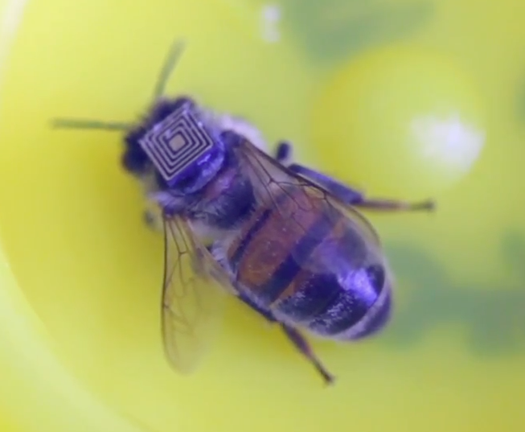

How do bees talk to each other?

Can you do a “waggle dance”?

# Introduction

When a bee finds something of interest, such as a source of pollen, it shares the information with other bees by flying back to the hive and doing a special manoeuvre called ‘*the waggle dance*’.

What information will the bee need to tell the other bees?

# Dancing outside

## Locating the beehive

Note the time of day and the date

Hit a stake into the ground. The shadow indicates the direction towards the sun. The direction towards the sun is zero degrees.

The base of the stake is the location of your hive. Mark a line on the ground where the shadow fell.

Take a photo or video along the shadow line in the direction of the sun. It should show not only the shadow but also other features in the distance, such as trees and buildings.

## Selecting the pollen source

Use *Google Earth* or *Google Maps* to find a relatively well known building, feature, landmark, shop, school, hospital or other location. It should be less than 10 km from your hive. This is the food you want to tell your fellow bees about.

Don’t tell anyone what you have chosen.

Write the name of the landmark on a piece of paper and give it to your teacher.

## Creating the dance

Make a silent video of one member of your group doing a waggle dance near the hive. The shadow line on the ground must be clearly visible in the video.

Orientate your dance in the direction of the landmark.

On the straight line section of the dance, waggle for one second for every kilometre that needs to be flown from the hive to the food.

## How effective is your dance?

Show your video to the class.

How many people correctly identified the pollen source?

# Dancing inside

Decide with your class the direction of the sun. Draw this angle accurately from the centre of the paper.

Measure the breadth and width of the classroom and identify a suitable scale.

Draw the classroom’s major features (e.g. the walls, windows and door) on the grid paper using the scale.

Identify a place in the classroom (e.g. the fish tank, the clock) as your pollen source. Don’t tell anyone. Your teacher will make sure that each group has a different place.

At some time during the day (so that no one else knows where your pollen source is) determine its direction and distance from the ‘hive’.

You can do your dance ‘live’ or video it. Use one second for every metre.