

Investigating the maths inside:

Bees with backpacks

Activity 5

Bee food

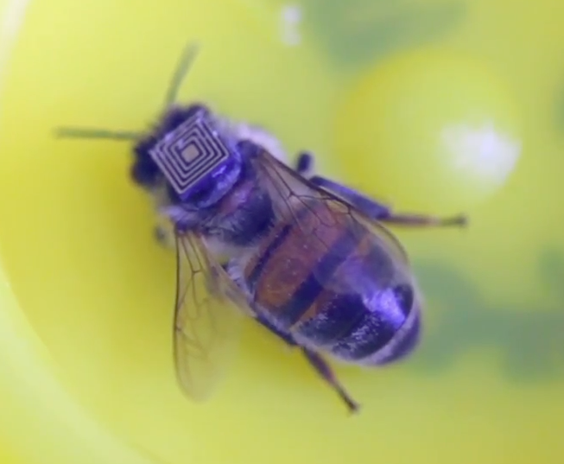

Imagine a world without bees: what would be different?

# Introduction

Bees produce honey, but they are also necessary for pollinating many other plants, which in turn produce the foods we eat.

# One day’s food

Think about a typical day and the food that you eat. List the different foods in a table. Include drinks as well.

Make sure that you record different foods separately (e.g. a ham and salad sandwich: bread, butter, ham, tomato, lettuce, cucumber, carrot).

This lists food crops that are pollinated by bees:

<https://en.wikipedia.org/wiki/List_of_crop_plants_pollinated_by_bees>

Identify which of the foods you have listed may have been ‘assisted’ by bees. Share your data with the rest of the class.

What percentage of the total amount of food was assisted by bees? What type of food was most affected?

Display your data appropriately.