

Investigating the maths inside:

Big data, better hospitals

Activity 3

Difficult to easy



How can we simplify, represent and interpret complex information?

# Introduction

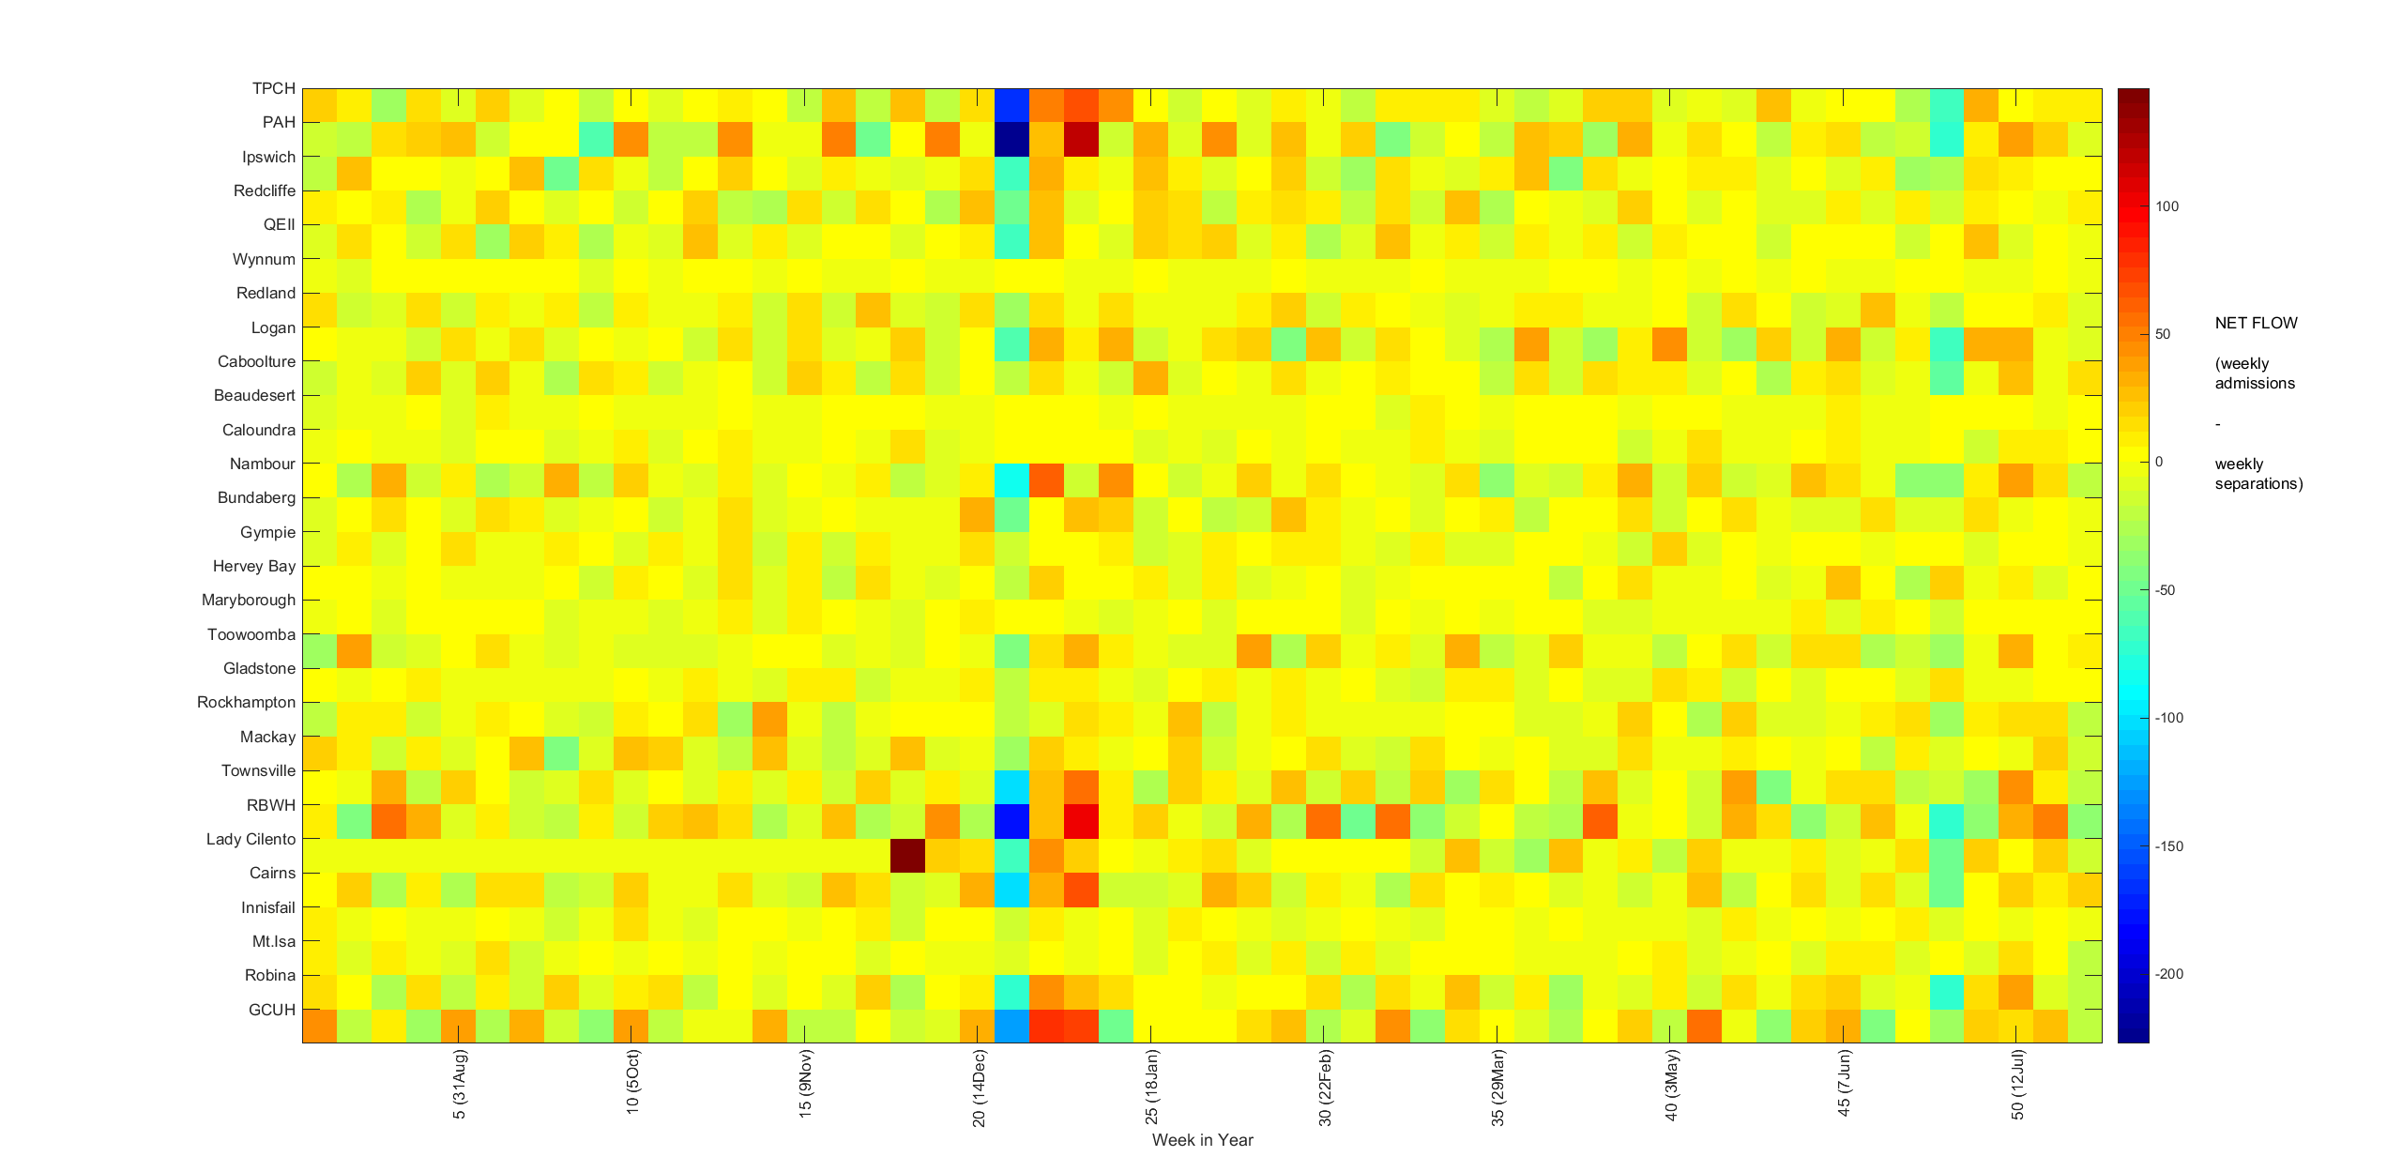

Have you ever seen or used a graph like this one?

Sometimes information is too complex to be displayed using the usual graphs learned about in school. How do you choose a graph to represent complex information? How can you be sure that the graph will be interpreted accurately? These are questions that face scientists often.

*The data used in this activity have been provided by Queensland Health’s Healthcare Improvement Unit and are used with their approval.*

# What does the data show?

Conducting a survey to find out how students get to school is a familiar mathematical activity. You may have done this for your class or even for your whole year level. The table below contains data on modes of travel from every year level.

|  |  |  |  |  |  |
| --- | --- | --- | --- | --- | --- |
| **Year level** | **Walk** | **Bus** | **Bike** | **Driven in car** | **Drive yourself** |
| **Year 7** | 43 | 29 | 12 | 40 | 0 |
| **Year 8** | 39 | 30 | 15 | 36 | 0 |
| **Year 9** | 45 | 24 | 19 | 28 | 0 |
| **Year 10** | 50 | 40 | 18 | 21 | 1 |
| **Year 11** | 30 | 45 | 11 | 22 | 12 |
| **Year 12** | 25 | 20 | 8 | 16 | 32 |

Look carefully at the data. What do you notice? What values are similar and what values are different? What general statements can you make about how the students of this particular school students travel?

# Which graph is best?

Look at the first slides of the PowerPoint ‘Which graph is best?’ These slides show six different ways of using Excel to graphically represent the travel data.

Which graph is best? Why?

# Is there a better graph?

The spreadsheet ‘Heat-map data’ contains data on the number of admissions for a large Queensland hospital in the month of March. The admissions are recorded hourly using 24-hour clock time. Your task is to draw a heat-map of this data and interpret the results.

Watch the video ‘How to create a cool heat-map in Excel’ <https://www.youtube.com/watch?v=CEGSBpNUZQ4> .

There are further instructions in ‘How to create a heat-map in Excel’.

Examine the heat-map carefully and write a short report on your findings. Can you explain why these patterns might occur?

# More heat-maps

Examine closely the final two graphs on the PowerPoint. These are ‘time-and-date-analysis’ heat-maps of:

* Treatment times for patients who leave the Emergency Department
* Patients being admitted to the Emergency Department

Provide an initial analysis of what you think the graphs are showing. Look for similarities and differences between the two graphs to help with your analysis. Share your findings with the class.

Was understanding the heat-maps easy or difficult? How might you improve them?