

Investigating the maths inside:

Prawns for profit

Activity 4

Selective breeding

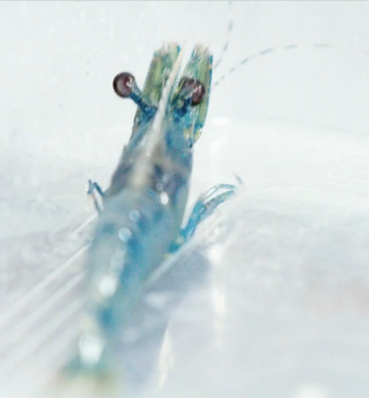What do you know about the phrase ‘selective breeding’?

What makes ‘first cousins’ different to ‘double cousins’?

Why do farmers need to exercise some degree of care when their animals produce offspring?

# Prawns that grow faster!

In the wild, black tiger prawns take about 18 months to become fully grown. It is estimated that 40 to 50% of wild prawns do not make it to full size.

The video shows prawns which are part of a selective breeding program. One of the aims of the program is to produce prawns that grow quickly to the ideal size. Australian scientists and farmers have managed to breed domesticated black tiger prawns that reach the ideal size in five months. More than 90% of the farmed prawns reach this size prior to being harvested.

This has been achieved by carefully choosing prawns that have grown quickly, and using those prawns to breed others that would also (hopefully) grow quickly, as they pass on the desired genes.

The adult prawns shown swimming around in indoor tanks are called ‘brood stock’. Some of them are 35 cm long! The offspring of the brood stock become the prawns in the large outdoor ponds from which the crop is harvested.

# Inbreeding defects

One of the difficulties of selective breeding can be inbreeding. This can happen when animals that are closely related are mated. In the video, the indoor tanks contain carefully chosen mating pairs. Scientists use the DNA of these prawns to show that they are not closely related.

The prawns in the large outdoor ponds may be very closely related. They are harvested prior to reaching sexual maturity. Then the pond is emptied. This avoids inbreeding in the ponds.

Your teacher will give you the instructions for the *What could go wrong?* simulation.

## Calculating the inbreeding coefficient

In 1922, Sewall Wright came up with a mathematical method for describing the closeness of the biological relationship between two individuals. It is called the *coefficient of relationship*. He also defined the *coefficient of inbreeding* so that a single individual could be described on a scale from 0% to100%. A value close to 0% indicates that the individual’s ancestors are distantly related, whereas a value close to 100% indicates a high level of inbreeding.

This article explains the *coefficient of relationship* and the *coefficient of inbreeding:*

<https://en.wikipedia.org/wiki/Coefficient_of_relationship>

# Example 1: Half siblings

# Prawns A, B and C are completely unrelated (and not inbred).

# Prawn A is mated with Prawn B to produce Prawn D.

# Prawn B is mated with Prawn C to produce Prawn E.

Later, Prawn D is mated with Prawn E to produce Prawn F.

Calculate Prawn F’s inbreeding coefficient.

**Solution:**

This could be represented as follows:

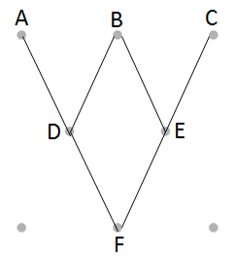

F is said to be ‘inbred’ because B is a **common** ancestor.

There are **three** ancestors of F in this inbreeding loop: F-D-B-E-F.

F’s **inbreeding coefficient** is calculated as follows:



**Note:** If A, B or C were also inbred, then F’s coefficient would be higher

# Example 2: Full siblings

# A and B are mated and produce C.

Later they are mated again and produce D.

Later, C and D are mated and produce E.

Calculate E’s inbreeding coefficient.

**Solution:**

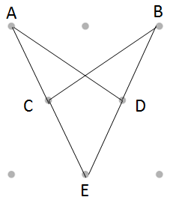

E is said to be ‘inbred’ because A and B are common ancestors.

There are **three** ancestors of E in the inbreeding loop E-C-A-D-E.

In addition, there are **three** ancestors of E in the inbreeding loop E-C-B-D-E.

F’s **inbreeding coefficient** for this is calculated as follows:



Now try a few for yourself from the *Coefficient of inbreeding* activity.

## Effects of Inbreeding

Which of the offspring in the examples you have completed is most at risk of serious health conditions? Explain.

Write a short report to explain why prawn farmers and animal breeders need to exercise a degree of caution when breeding offspring.