

Investigating the maths inside:

Modelling climate changes

Information for teachers

**

*Maths Inside* is a project funded by the Commonwealth Department of Education and Training under the Australian Maths and Science Partnership Programme.

The aim of *Maths Inside* is to increase engagement of students in mathematics by using rich tasks that show the ways mathematics is used in real world applications.

# About this module

**This resource was developed by**

David Andrew

Kym Linke

Kate Manuel

Stuart Palmer

**UTS project team**

Dr Marco Angelini (Project Manager)

Dr Mary Coupland (Project Director)

Assoc/Professor Anne Prescott (Project Director)

This module consists of the video *Modelling climate changes* and the following activities:

Activity 1: How do you measure rain? (Years 6 to 9)

Activity 2: Two hundred kilometres away (Years 7 to 9)

Activity 3: What might happen if…? (Years 6, 7 &9)

# Feedback

Feedback from teachers about these classroom activities would be appreciated. Please complete the form at <http://tiny.cc/mathsinsidefeedback>.

# Background

There is a saying “climate is what you expect and weather is what you get”.

Understanding climate change is very difficult for most people, especially when the weather we experience is different from the information we are given by scientists about the climate changing. The difference is that weather reflects short-term conditions in the atmosphere, while climate is the average daily weather at a location over a long period of time.

Scientists make predictions about future climate using computer models that have been developed from taking averages about rainfall and temperature over long time-periods and over large areas of the earth.

Activity 1: How do you measure rain?

Major changes in climate can mean major changes in rainfall (either increasing or decreasing) which in turn can affect agriculture, amenity and infrastructure needs.

Rain is measured in millimetres (a length measure) not millilitres (a volume measure).

Students estimate a square metre then find some objects that have a volume of approximately one cubic metre to assist them in discovering how a millimetre of rain is measured. Students draw shapes and find real objects to help them better understand the relationship between area and volume, related to squares and cubes. They change metric units.

There is an opportunity to make a rain gauge to further their understanding of a millimetre of rain.

# Why do this?

Students better understand the link between area and volume, and can relate it to a relevant context.

Designing and testing a rain gauge brings in aspects of STEM, especially science and engineering.

Proportional thinking is needed to convert the absolute measurement of the rain gauge to the relative measurement.

# Australian Curriculum links

#### Year 6: Measurement and geometry - Using units of measurement

Connect [decimal](http://v7-5.australiancurriculum.edu.au/glossary/popup?a=M&t=Decimal) representations to the metric system [(ACMMG135)](http://v7-5.australiancurriculum.edu.au/curriculum/contentdescription/ACMMG135)

Convert between common metric units of length, mass and [capacity](http://v7-5.australiancurriculum.edu.au/glossary/popup?a=M&t=Capacity) [(ACMMG136)](http://v7-5.australiancurriculum.edu.au/curriculum/contentdescription/ACMMG136)

Solve problems involving the comparison of lengths and areas using appropriate units [(ACMMG137)](http://v7-5.australiancurriculum.edu.au/curriculum/contentdescription/ACMMG137)

Connect [volume](http://v7-5.australiancurriculum.edu.au/glossary/popup?a=M&t=Volume) and [capacity](http://v7-5.australiancurriculum.edu.au/glossary/popup?a=M&t=Capacity) and their units of measurement [(ACMMG138)](http://v7-5.australiancurriculum.edu.au/curriculum/contentdescription/ACMMG138)

#### Year 7: Measurement and geometry - Using units of measurement

Calculate volumes of rectangular prisms[(ACMMG160)](http://v7-5.australiancurriculum.edu.au/curriculum/contentdescription/ACMMG160)

#### Year 8: Measurement and geometry – Using units of measurement

Choose appropriate units of measurement for area and [volume](http://v7-5.australiancurriculum.edu.au/glossary/popup?a=M&t=Volume) and convert from one unit to another [(ACMMG195)](http://v7-5.australiancurriculum.edu.au/curriculum/contentdescription/ACMMG195)

#### Year 9: Measurement and geometry – Geometric reasoning

Solve problems using [ratio](http://v7-5.australiancurriculum.edu.au/glossary/popup?a=M&t=Ratio) and scale factors in [similar](http://v7-5.australiancurriculum.edu.au/glossary/popup?a=M&t=Similar) figures [(ACMMG221)](http://v7-5.australiancurriculum.edu.au/curriculum/contentdescription/ACMMG221)

# Getting started

Have a classroom discussion based on the questions about rainfall. Students should be able to talk about the effects of droughts and floods. They should be aware of the significant differences in rainfall amounts that can occur in different years.

# How much is 1 millimetre of rain?

Have students guess, estimate, discuss and then check their answers to the introductory questions.

A millimetre of rainfall is one litre of water to a depth of 1mm over 1 square metre

(i.e. 1000m x 100cm x 0.1cm = 1000cm3 = 1000 millilitres = 1 litre)

Redo the calculations using millimetres, then metres.

## Find a square metre

It is important for student to realise that measuring area in square metres does not mean that the shape has to be a square! Starting with a square then moving to different shaped rectangles makes a logical progression. Some students will be ready to move onto triangles and circles for a further challenge.

Students are likely to construct a rectangle with proportions of 2m by 0.5m because that is a simple calculation. Encourage them to try differently shaped rectangles: “Can we make a fatter rectangle?” “What about a really long, skinny one?”

Students should now know that filling these shapes with water to a depth of one millimetre is how one millimetre of rainfall is measured.

#### You may wish to make a square metre to keep in the classroom.

Measure and tape two pages of a broadsheet newspaper together.

Loosely roll four, one-metre lengths for the edges.

Cut a page in halves and roll tightly to form the joiners. Then fold these joiners in halves.

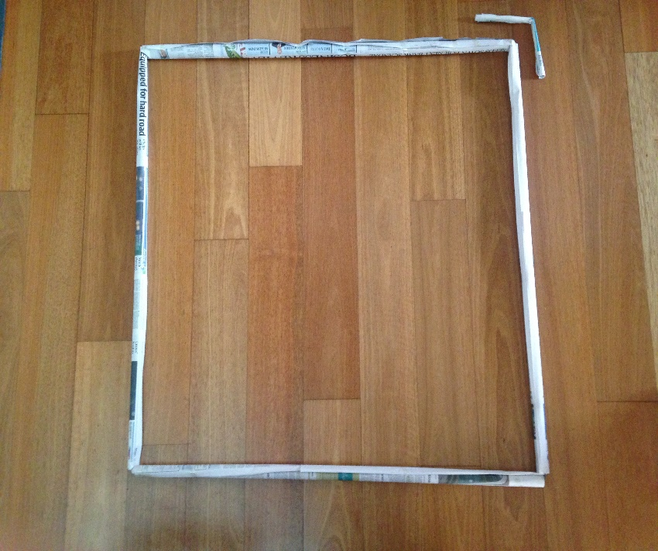

## Find a cubic metre

Finding some objects that are about a cubic metre in size would make a good homework exercise. Otherwise students can look around the school buildings to find possible objects.

By answering the questions in this section they should gain a better understanding of how rainfall is measured.

#### You may wish to make a cubic metre to keep in the classroom.

To make a one-metre cube it will be necessary to put pages together (a broadsheet is better for this) to make the desired lengths.

Tape two sheets together to make a metre. A broomstick or long piece of dowel will make it easier to roll the paper.

Joiners can be made using one sheet of rolled newspaper, doubled over. Alternatively, straws can be pushed inside one another to join them.

Another way of making a cubic metre is to ask students to make one-metre long straws by pushing straws inside of each other. These can be taped together to make a square metre. Then the square meters can be taped together to make the sides of a cubic metre.

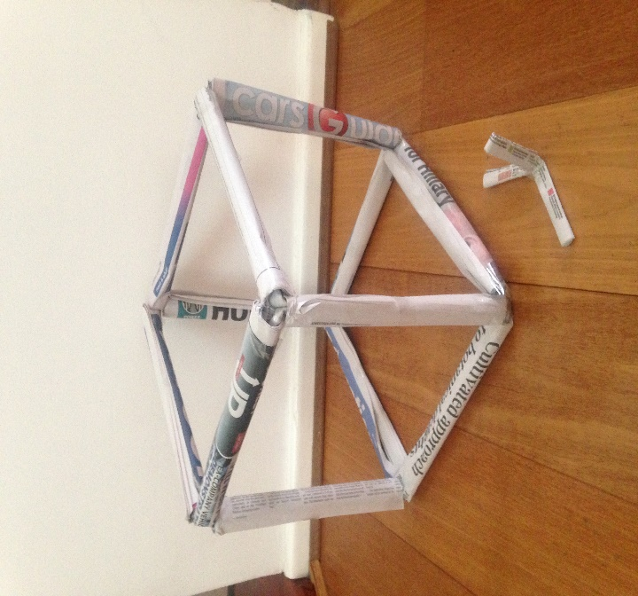

# Make a rain gauge

Making a rain gauge is easy.

This YouTube video shows how: <https://www.youtube.com/watch?v=QOzdcM-YZ2U>

## Calibrate it!

What is the most important fact to know to make an accurate rain gauge? Essentially students need to have made the connection that 1 litre of water in any container makes 1mm of rain, even if it doesn’t measure 1 mm! Students need to use a scale factor to convert their measure to the ‘correct’ measure; a good example of proportional thinking.

# Resources

Rulers, preferably metre rulers or measuring tapes

For the rain gauges:

* Empty plastic water-bottles
* Box-cutters or similar
* Jelly
* Rulers
* Markers
* Paper clips

To make a square metre and a cubic-metre (optional):

* Tabloid and broadsheet newspapers
* Sticky tape
* Masking tape
* Scissors
* Rulers
* 2 to 3 packets of 100 straws

# Further ideas

Investigate historical units of rainfall measurements, such as ‘points’.

How much water does a dam hold?

How much water can be held in a reservoir?

Activity 2: Two hundred kilometres away

Students make predictions and use calculations to understand the rainfall patterns in their local area compared to places 200 kilometres away.

The differences in rainfall in places 200km from the school are used to help students appreciate the difficulties of making measurements over the whole surface of the earth, and how averaging can affect those measurements.

They explore modelling techniques by dividing Australia into 200 km squares using a variety of methods to examine the variability in the climate.

(A 200 kilometre square has sides of 200 km and an area of 40 000 square kilometres)

Why do this?

The scientists in the video describe dividing up the surface of the earth into 200 km squares. The study of the differences in rainfall over those 200 km squares can lead to a better understanding of how predictions about future climate possibilities are made, and the difficulty of making predictions from taking averages of averages over this area.

They better understand the climate of their local area and that of Australia generally. This activity places the sciences into a relevant and realistic context.

Students become aware of the limitations of certain kinds of mathematical models.

# Australian Curriculum links

#### Year 7: Statistics and probability – Data representation and interpretation

Identify and investigate issues involving numerical data collected from primary and secondary sources (ACMSP169)

Calculate mean, median, mode and range for sets of data. Interpret these statistics in the context of data ACMSP171

#### Year 8: Measurement and geometry – Using units of measurement

Choose appropriate units of measurement for area and [volume](http://v7-5.australiancurriculum.edu.au/glossary/popup?a=M&t=Volume) and convert from one unit to another [(ACMMG195)](http://v7-5.australiancurriculum.edu.au/curriculum/contentdescription/ACMMG195)

#### Year 8: Statistics and probability – Data representation and interpretation

Investigate the effect on individual data values, including outliers, on the mean and median ACMSP207

Choose appropriate units of measurement for area and [volume](http://v7-5.australiancurriculum.edu.au/glossary/popup?a=M&t=Volume) and convert from one unit to another [(ACMMG195)](http://v7-5.australiancurriculum.edu.au/curriculum/contentdescription/ACMMG195)

#### Year 9: Measurement and geometry – Geometric reasoning

Solve problems using [ratio](http://v7-5.australiancurriculum.edu.au/glossary/popup?a=M&t=Ratio) and scale factors in [similar](http://v7-5.australiancurriculum.edu.au/glossary/popup?a=M&t=Similar) figures [(ACMMG221)](http://v7-5.australiancurriculum.edu.au/curriculum/contentdescription/ACMMG221)

# Getting started

Discuss the modelling techniques described in the video. The scientists use a variety of methods, one of which relies upon dividing an area into smaller blocks. In this case the blocks are 200 km squares. Why do they do this?

# How much difference in the rainfall?

## Places 200 km away

Your choices will very much be influenced by your school location. Try to get some places that are likely to have different rainfalls with different geographical features, for example, mountains or deserts. Students might choose to be more methodical and choose different directions, such as North, South, East and West. They may also want to discuss what ‘approximately’ means in this context.

Students’ estimates of rainfall will very much depend upon local knowledge. Other information that could help with closer estimates would be height above sea-level, proximity to the modifying effects of bodies of water, prevailing winds etc. This is a good opportunity to tie in with the sciences.

Actual rainfall can be readily found with a google search.

Tully in Queensland is usually cited as the wettest place in Australia with an annual average rainfall of over 4000 mm and the highest ever annual rainfall of 7900 mm in 1950. It is an interesting exercise for students to estimate how high that really is!

The driest place(s) are around Lake Eyre in South Australia, for example, Mulka Bore with an annual rainfall of 100 mm. It would be interesting to compare maximum temperatures with minimum rainfall.

## Choose two weather stations

The Bureau of Meteorology website (<http://www.bom.gov.au/climate/data/index.shtml> ) has rainfall data for various weather stations. Select the one nearest to your school and another close to one of the ‘200 km places’. Students may wish to use different weather stations.

It will be necessary to experiment with the site to get the information required. Some stations have months missing in some years so be aware of this as students start selecting places. There is the facility to have daily or monthly rainfall; monthly data is more manageable.

The questions are a prompt to discuss what the average means compared to each of the monthly totals, that is, does the average paint a sensible picture of the rain each month?

# Dividing up Australia

Provide groups of students with scaled maps of Australia. Estimates should probably begin with the ‘dimensions’ of Australia. This is a good scale-reading exercise.

What is the best way to divide up Australia into 200 km squares? Australia has an approximate area of 7.692 million km2 or 7 692 024 km2. There should be an interesting discussion about what you might divide by and if that is accurate enough, especially as Australia is not a regular shape. That is, is the number of 200 km squares the area of Australia divided by 40 000, or should it be done as a mapping exercise? Can we subdivide into a number of more easily calculated shapes, such as triangles, rectangle etc?

The next discussion points are intended to get students to think about the idea of ‘averaging averages’ over the whole of Australia and then extend that idea to the earth’s surface. This should lead to a discussion about making long term predictions based on data that is averaged over large distances and long time periods.

What further information is required to make predictions about rainfall into the future?

It will help your discussion to think about the difference between weather and climate.

## Conclusion

Reconsider the discussion you had about rain before doing the activities. Why is it important to have accurate information about rainfall when making predictions about climate change and possible rainfall changes into the future?

Students could write a summary of the activity using their own experiences or information from the media.

For example:

* Building houses in areas that are prone to flooding.
* The increasing population in Australia and why the majority of Australians live near the coast.
* Development of agriculture and feeding a larger population.

# Resources needed

Maps of Australia with scale

Internet access for gathering data from the Bureau of Meteorology

Activity 3: What might happen if…?

Major changes in climate can mean changes in rainfall and temperature (either increasing or decreasing) which in turn can affect agriculture and/or recreational activities.

Students research the kind of agricultural activities that exist in their area (food crops, livestock etc) and the type of climate necessary to support that activity. They may also consider recreational activities that might be affected by changes in climate (ski fields, water sports etc).

They build a picture of the climate of their local area using information from reliable sources such as the Bureau of Meteorology. Students consider the suitability of different kind of averages.

# Why do this?

Students build a sound picture of their local climate, examining many factors. They better understand the climatic conditions needed for local agricultural activities.

Students understand that comparatively small changes in climate can have significant effects on agriculture. They logically explore various scenarios. Students understand that different mathematical models can give different ‘answers’ and that there are limitations when extrapolating data.

Students understand the conflict that can arise from the different perspectives on climate of, say, farmers and the sportspeople.

# Australian Curriculum links

#### Year 6: Statistics and probability – Data representation and interpretation

Interpret secondary data presented in digital media and elsewhere (ACMSP148)

#### Year 7: Statistics and probability – Data representation and interpretation

Identify and investigate issues involving numerical data collected from primary and secondary sources (ACMSP169)

Describe and interpret data displays using median, mean and range (ACMSP172)

#### Year 9: Statistics and probability – Data representation and interpretation

Identify everyday questions and issues involving at least one numerical and at least one categorical variable, and collect data directly and from secondary sources (ACMSP228)

# Getting started

Begin with a discussion about your local area (it may extend for many kilometres depending on where you are).

What agriculture exists? Prompt students with suggestions of different types of food crops (grains, fruit, vegetables, fungi) and different kinds of animal farming (poultry, bees, cattle, pigs, fish) plus ‘wild’ agriculture (kangaroos, bush tucker, seafood). Students may need to do some research if they are unfamiliar with what is produced locally.

Discuss students’ perceptions of their local climate. What is it like? Do they know how much rain falls? And when it rains most often? What the average temperature is? It will be easier if students identify the characteristics of each the seasons.

There is an opportunity to incorporate Indigenous weather knowledge: the different seasons and their indicators, and seasonal lifestyles.

Students need to be clear about the differences between climate and weather.

# Build a picture of your climate

There is a lot of information on the BOM website.

Depending on your locale and the type of agricultural activities, some information will be more important (e.g. potential frost days, days of rain, number of cyclones). Students need to understand that these data are averages. One very important factor in terms of climate is variability.

Depending on your context, students can explore Indigenous weather knowledge, in particular the interpretation and indicators of seasons at <http://www.bom.gov.au/iwk/index.shtml>. The site also explains the plant and animal indicators as well as the seasonal lifestyle activities. A comparison between the number and type of seasons in Indigenous knowledge and the ‘traditional’ four seasons is an interesting exercise.

Students prepare a short report. It is valuable to discuss what different students thought was important and why. The class can then collectively produce a reasonably comprehensive summation.

# How much change?

The climate change trend maps on the BOM website can be set to show mean temperature trends and annual rainfall trends based on actual data. Discuss what a trend is and the reliability of extrapolation. This can be a good time to remind students of lines of best fit.

The maps default to the period from 1970 to 2017 but can be changed to a longer period. Comparing a longer period to a shorter one is in itself is an interesting exercise.

(Note that the data is given as OC every decade for temperature, and mm per decade for rainfall, so students will need to approximate the change.)

Students may be surprised at how ‘little’ the change is in their area (for example, on long term trends, Adelaide’s mean annual temperature has increased by approximately 1.1OC (upper limit) and its rainfall decreased by 100 mm (upper limit)).

# This website has been created by climate scientists so that people can investigate various scenarios.

[www.climatechangeinaustralia.gov.au/en/climate-projections/climate-analogues/analogues-explorer/](http://www.climatechangeinaustralia.gov.au/en/climate-projections/climate-analogues/analogues-explorer/)

Note that the temperature change is given in OC but the rainfall is given as a percentage change.

Students find places that have a similar climate to their local area. They then make changes to the temperature and rainfall and discover a new set of places that match the new climate. The first changes should be modest to match the predictions. What effect might these changes have on agriculture?

Students should also try varying one factor at a time. Which has the most significant effect? What combinations of climate changes give the best or worst outcomes? Remember that some places might become more livable or more productive, not less!

# Disaster scenarios

Students could also investigate extreme scenarios to find out what could happen when the climate changes significantly, for example, if the average temperature increased by 5 degrees and the rainfall either increased or decreased by 40%. They could look not only at their area but also at other places of interest, such as capital cities, deserts, or snow fields.

If considered suitable for your students, you could introduce this section with a trailer from a disaster movie. such as ‘Geostorm’ <https://www.youtube.com/watch?v=ey8wmNtwzoI>

or ‘The day after tomorrow’ <https://www.youtube.com/watch?v=MU5lJ-5c_WA>

Be aware that some scenes could be distressing (and that the second trailer has several grammatical errors!).

# Further ideas

The Monash University website <https://monash.edu/research/simple-climate-model/mscm/overview_i18n.html?locale=EN> has a model that can be used to explore climate change over time. It does require some working with to appreciate what is possible.

Some climate changes may affect sea levels because of temperature increases and the melting of the polar ice-caps. Maps predicting these changes for Australia can be found at ozcoasts.gov.au