
Unit NE3: Thinking and Reasoning
Years 8 and 9
Number and Algebra / Measurement and Geometry
Helen Pryor
Nerang Cluster
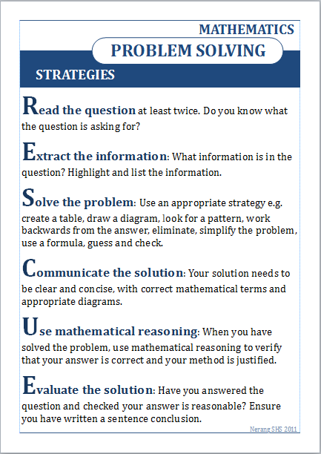
RESCUE POSTER
Thinking and Reasoning Tasks Sample year 8
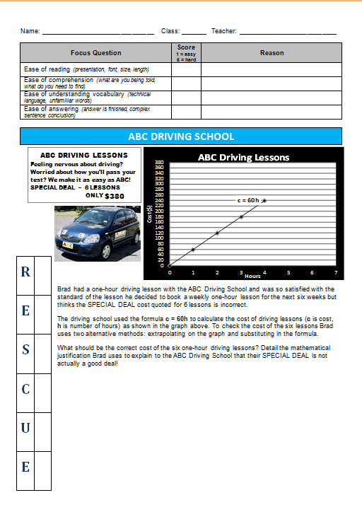
Thinking and Reasoning Tasks Sample year 9

